John Li
Data Architect
Compugen

CATAS User Guide
Compugen Azure MSP Confidential

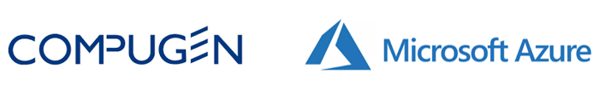

Confidentiality and Intellectual Property Information

Confidentiality
This document has been prepared by Compugen, specifically for Azure MSP team with regards to the Azure Migration project. This report is proprietary to Compugen and is intended for use internally.

Trademark Acknowledgments

Any company and product names used herein may be the trademarks or registered trademarks of their respective companies.

Copyright Notice

Copyright © Compugen 2020

All Rights Reserved

No part of this document may be reproduced in any form, including photocopying or transmission electronically to any computer, without prior written consent of Compugen

Document Revision History
Revision | Date | Revised by | Description
0.1 | 8/25/2020 | John Li | Initial draft
0.2 | 8/26/2020 | John Li | Changed web interface color
0.3

Table of Contents

Confidentiality and Intellectual Property Information 1
Document Revision History 2
1. Overview 4
1.1 Reference Documents 5
2. Install CATAS 6
2.1 Install DMA 6
2.2 Install CATAS 6
2.3 Install CATAS Web Interface 6
3. CATAS Command Line Interface 8
3.1 Validation Module 8
3.2 Assessment Module 9
3.3 Collection Module 10
4. CATAS Web Interface 12
4.1 Validate Server File 12
4.2 Assessment Module 13
4.3 Collection Module 15
4.4 Management Module 17
Appendix A – Glossary 18

Table of Tables
Table 1 – Reference Document 5
Table 2 Server List CSV File 8

Table of Figures
Figure 1 CATAS Architecture 4
Figure 2 Sample Server List CSV File 8
Figure 3 CATAS Home Page 12
Figure 4 Validate Module 13
Figure 5 Assessment Module 14
Figure 6 Workload Collection and Cost Estimation 16
Figure 7 Assessment Management 17

Overview

CATAS (Compugen Assessment Tool for Azure SQL) is Compugen’s SQL assessment tool for SQL Server migration to Azure SQL platform. CATAS is built on top of several Microsoft tools and Figure 1 Shows the architecture:

Figure 1 CATAS Architecture

CATAS is built based on Windows PowerShell and SQLCMD tool. For source SQL Server database assessment and feature compatibility, it leverages Microsoft Data Migration Assistant (DMA). It’s able to collect on-premise SQL Server workload and analyze the result with Azure Database Migration Service (DMS). Based on the SQL Server workload, it will make target SQL recommendation as well as cost estimation. A web interface based on Python and Flask is provided to help user run the assessment although you may choose to execute the assessment directly from command line. CATAS is trying to overcome some shortcomings of DMA during SQL Server migration assessment stage and following is the summary:
- Reduce manual intervention for SQL Server assessment even for large number of SQL instances
- Guarantee repeatable assessment with same configuration
- Capture source SQL Server workload automatically
- Recommend target configuration for both Azure SQL Database and Managed Instance
- Provide target cost estimation based on user preference
- Automate the whole SQL database assessment process

This user’s guide provides you detailed procedure for how to install CATAS, run assessment and recommendation on command line or through web interface, and manage run configurations.

Supported Source and Target
CATAS is based on Microsoft DMA to do all the assessment and it supports following SQL Server version as data source:
- SQL Server 2005
- SQL Server 2008
- SQL Server 2008 R2
- SQL Server 2012
- SQL Server 2014
- SQL Server 2016
- SQL Server 2017
And following as data target:
- SQL Server 2012
- SQL Server 2014
- SQL Server 2016
- SQL Server 2017 on Windows and Linux
- SQL Server 2019 on Windows and Linux
- Azure SQL Database single database
- Azure SQL Managed Instance
- SQL server running on an Azure Virtual Machine

Reference Documents

Document Title | Document URL
Overview of Data Migration Assistant | https://docs.microsoft.com/en-us/sql/dma/dma-overview?view=sql-server-ver15
Azure Database Migration Service | https://azure.microsoft.com/en-us/services/database-migration/
Using Python on Windows | https://docs.python.org/3/using/windows.html
Windows PowerShell | https://docs.microsoft.com/en-us/powershell/scripting/overview?view=powershell-7
Microsoft® Data Migration Assistant v5.2 | https://www.microsoft.com/en-us/download/details.aspx?id=53595
Table 1 – Reference Document

Install CATAS

Supported Environment

OS: Windows 10, Windows Server 2012, Windows Server 2016
.NET Framework 4.7.2 64-bit or above

Install DMA

Go to Microsoft DMA download site to download DMS executable and follow the instruction for installation. Current release is Microsoft Data Migration Assistant v5.2.

Install CATAS

- Download CATAS package (catas.zip) https://github.com/johnli88/catas/archive/master.zip or clone it directly from GitHub https://github.com/johnli88/catas.git.
- Create a working directory, say C:\temp\catas, and unzip the file under the directory. Move to catas directory:
cd C:\temp\catas
- You need PowerShell version 5.0 or above. Run following command to check the version from a PowerShell terminal:
$PSversionTable
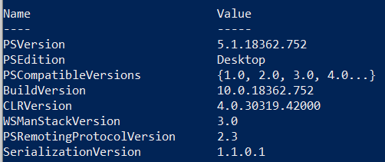
- Make sure PowerShell module SqlServer and ImportExcel are installed:
Install-Module -Name SqlServer -Force
Install-Module -Name ImportExcel -Force

Install CATAS Web Interface

If you only use the command interface, you may skip this section.

CATAS web interface is implemented with Python and Flask so you must install Python 3.7 or above. You may install Python by following https://docs.python.org/3/using/windows.html if necessary. Also, you may check if you already have tool PIP installed or not:
pip help

If you need to install PIP tool, please refer How to Install PIP to Manage Python Packages on Windows. You need to install all the dependencies by running follow command:
pip install -r requirements.txt

CATAS Command Line Interface

CATAS function can be categorized into following four modules:
- Validation: this module validates SQL Server connection information provided to ensure its correctness.
- Assessment: this module assesses on-premise SQL Server database feature parity and compatibility level.
- Collection: this module collects SQL Server workload performance counters for Azure configuration recommendation and cost estimation.

We will discuss common commands for each of the modules.

Validation Module

One advantage of using CATAS is that it accepts a server CSV file for large number of SQL Server instances. The fields of such a server connection list are explained in Table 2.

Filed | Field Name | Values
1 | Host | Host full name including domain or IP address
2 | User | User ID to log into the server host; use current user if omit
3 | Password | User ID password for server login; use current user password if omit
4 | Instance | SQL server instance name; default instance if omit
5 | Port | SQL server port #; 1433 used if omit
6 | SqlUser | SQL server login ID; current user is used if omit
7 | SqlPassword | SQL server login password; current user password is used if omit
8 | DBlist | List of databases to be assessed; databases are separated by comma “,” so the list must be quoted; all databases inside the instance if omit
9 | Comment | Any text for your own purpose
Table 2 Server List CSV File

Here is a sample of sever list:

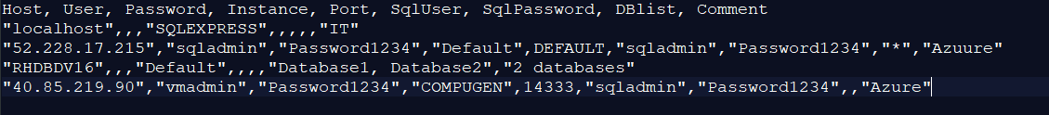
Figure 2 Sample Server List CSV File

Figure 3 shows a sample server list CSV file:
- Line 1: CSV file header
- Line 2: describes a local host with default SQL Server Express instance
- Line 3: SQL Server host 52.228.17.215 with user sqladmin and password Password1234. It uses default SQL instance and port number. SQL Server user ID is sqladmin and password Password1234. Assess all the databases.
- Line 4: describes SQL Server host RHDBDV16 with all default values except only two databases are assessed.
- Line 5: describes SQL Server host 40.85.219.90 with no default values except all databases in this instance are assessed.

Validation Command Examples

Validate all SQL server host connections for input configuration file my-sql-server-list.csv:

- catas.ps1 -AssessName "myAssessment" -InputFile "C:\temp\my-sql-server-list.csv"
-ValidateHost

Note assessment name is required even though it has no impact to the server connection validation. You may put any text for assessment name.

Validate all SQL server instance connections for input configuration file my-sql-server-list.csv:

- catas.ps1 -AssessName "myAssessment" -InputFile "C:\temp\my-sql-server-list.csv"
-ValidateSql

Validate both SQL server host and instance connections for input configuration file my-sql-server-list.csv:

- catas.ps1 -AssessName "myAssessment" -InputFile "C:\temp\my-sql-server-list.csv"
-ValidateBoth

Assessment Module

Assess feature parity for all the servers from my-sql-server-list.csv and generate dma and json reports:

- catas.ps1 -AssessName "myAssessment" -InputFile "C:\temp\my-sql-server-list.csv"
-OutputFolder "C:\temp\output" [-Target TargetPlatform] [-ReportName ReportName]
-AssessType Feature

Note assessment name is required and a report name is optional. If report name is not provided, the assessment name will be used as the report name. You can also specify the target Azure platform with either SQLDB for SQL Database for SQLMI for SQL Managed Instance. The default is SQLDB.

Assess compatibility level for all the servers from my-sql-server-list.csv and generate dma and json reports:

- catas.ps1 -AssessName "myAssessment" -InputFile "C:\temp\my-sql-server-list.csv"
-OutputFolder "C:\temp\output" [-Target TargetPlatform] [-ReportName ReportName]
-AssessType Compat

Assess both feature parity and compatibility level for all the servers from my-sql-server-list.csv and generate dma and json reports:

- catas.ps1 -AssessName "myAssessment" -InputFile "C:\temp\my-sql-server-list.csv"
-OutputFolder "C:\temp\output" [-Target TargetPlatform] [-ReportName ReportName]
-AssessType Both

Note AssessType is optional in this case, i.e. default value is for both feature parity and compatibility level assessment.

Assess both feature parity and compatibility level for all the servers from my-sql-server-list.csv and generate dma and json reports with SQLMI as target platform:

- catas.ps1 -AssessName "myAssessment" -InputFile "C:\temp\my-sql-server-list.csv"
-OutputFolder "C:\temp\output" -Target SQLMI [-ReportName ReportName]
-AssessType Both

Evaluate recommendation for all the servers from my-sql-server-list.csv and generate json report:

- catas.ps1 -AssessName "myAssessment" -InputFile "C:\temp\my-sql-server-list.csv"
-OutputFolder "C:\temp\output" [-Target TargetPlatform] [-ReportName ReportName]
-AssessType Evaluate

Collection Module

Collect SQL server workload performance counts for 240 seconds for all the servers from my-sql-server-list.csv and generate csv report:

1. catas.ps1 -AssessName "myAssessment" -InputFile "C:\temp\my-sql-server-list.csv"
-OutputFolder "C:\temp\output" [-ReportName ReportName]
-AssessType Workload - WorkloadTime 240

Note assessment name is required and a report name is optional. If report name is not provided, the assessment name will be used as the report name. The AssessType must be Workload and the performance counter collection time is 240 seconds which is the minimum value. Default value is one hour while the recommended value is four hours during production peak time to ensure maximum transaction throughputs are captured.

Collect SQL server workload performance counts for 600 seconds for all the servers from my-sql-server-list.csv and generate csv report with report name myReport:

- catas.ps1 -AssessName "myAssessment" -InputFile "C:\temp\my-sql-server-list.csv"
-OutputFolder "C:\temp\output" -ReportName myReport
-AssessType Workload - WorkloadTime 600

Estimate Azure SQL DB & MI cost from performance count file workload-local.csv for all databases and generate reports:

1. catas.ps1 -AssessName "myAssessment" -CountFile "C:\temp\workload-local.csv"
-OutputFolder "C:\temp\output" -AssessType SKU
-SubscriptionId "0f81e775-ffff-4020-a53f-013122a792b8"
-TenantId "7d270c48-208d-ffff-ade1-e658c4ef4f18"
-ClientId "8dc6a081-3a6a-ffff-bc41-47550ee9aee2"

Note assessment name is required and a report name is optional. If report name is not provided, the assessment name will be used as the report name. The AssessType must be Workload and the performance counter collection. Since this operation accesses Azure Database Migration Service, you have to provide Azure tenant ID, subscription ID, and client ID. The final reports are in three different formats: tab separate CSV, json, and html.

Estimate Azure SQL DB & MI cost from performance count file workload-local.csv for databases AdventureWorksLT2014, AdventureWorks2014, AdventureWorksDW2014 and generate reports:

1. catas.ps1 -AssessName "myAssessment" -CountFile "C:\temp\workload-local.csv"
-OutputFolder "C:\temp\output" -AssessType SKU
-SubscriptionId "0f81e775-ffff-4020-a53f-013122a792b8"
-TenantId "7d270c48-208d-ffff-ade1-e658c4ef4f18"
-ClientId "8dc6a081-3a6a-ffff-bc41-47550ee9aee2"
-DatabaseNames '"AdventureWorksLT2014" "AdventureWorks2014" "AdventureWorksDW2014"'

Collect SQL Server workload performance count and estimate Azure SQL DB & MI cost based on SQL instances provided:

1. catas.ps1 -AssessName "myAssessment" -InputFile "C:\temp\my-sql-server-list.csv"
-OutputFolder "C:\temp\output" -AssessType WorkloadSKU - WorkloadTime 600
-SubscriptionId "0f81e775-ffff-4020-a53f-013122a792b8"
-TenantId "7d270c48-208d-ffff-ade1-e658c4ef4f18"
-ClientId "8dc6a081-3a6a-ffff-bc41-47550ee9aee2"

Note this command will collect performance counter for all SQL Server specified in the input file for one hour. The final report name will have following format:
workload-<SQLServerHostName>.csv (comma separated performance counter CSV file)
prices-<SQLServerHostName>.tsv (tab separated target configuration and cost estimation CSV file)
prices-<SQLServerHostName>.json (target configuration and cost estimation json file)
prices-<SQLServerHostName>.html (target configuration and cost estimation html file)
Here SQLServerHostName is the SQL server host name taken from my-sql-server-list.csv file, i.e. for each SQL Server instance there are four different reports generated.

CATAS Web Interface

To start CATAS web service, you have to run following command:
$env:FLASK_APP = "catas.py"
python -m flask run

Open your Chrome browser and go to http://127.0.0.1:5000/. You should see CATAS home page:

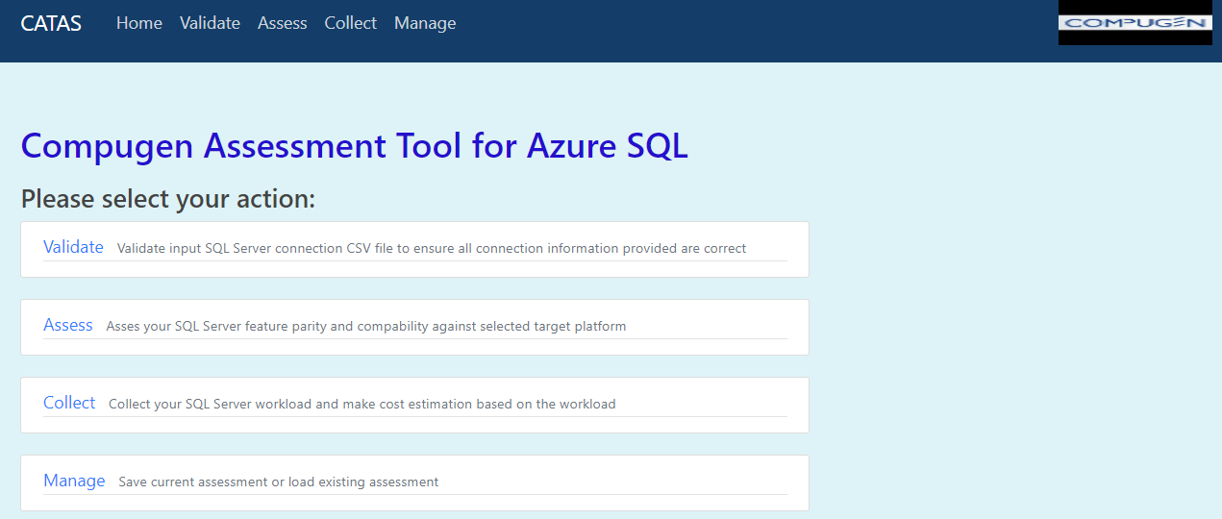
Figure 3 CATAS Home Page

Follow the module to execute the assessment your choices.

Validate Server File

Click Validate, you’ll be presented with server CSV file validation page as shown in Figure 4.

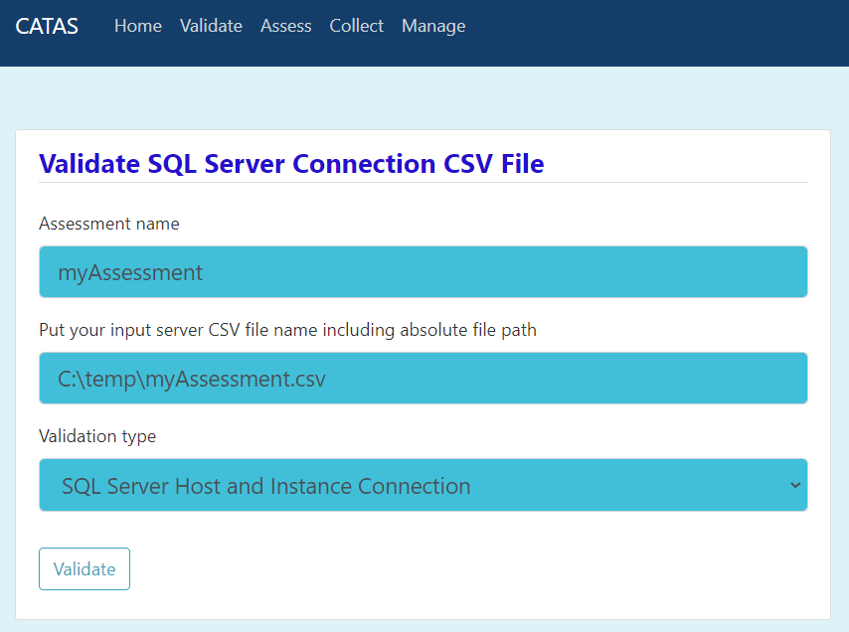
Figure 4 Validate Module

Validation module to make sure your server CSV file is correct by connect to the servers using provided credentials. You may choose validate server host connection, SQL Server connection or both.

Assessment Module

The Assessment module allows you to do SQL Server migration assessment as shown in Figure 5.

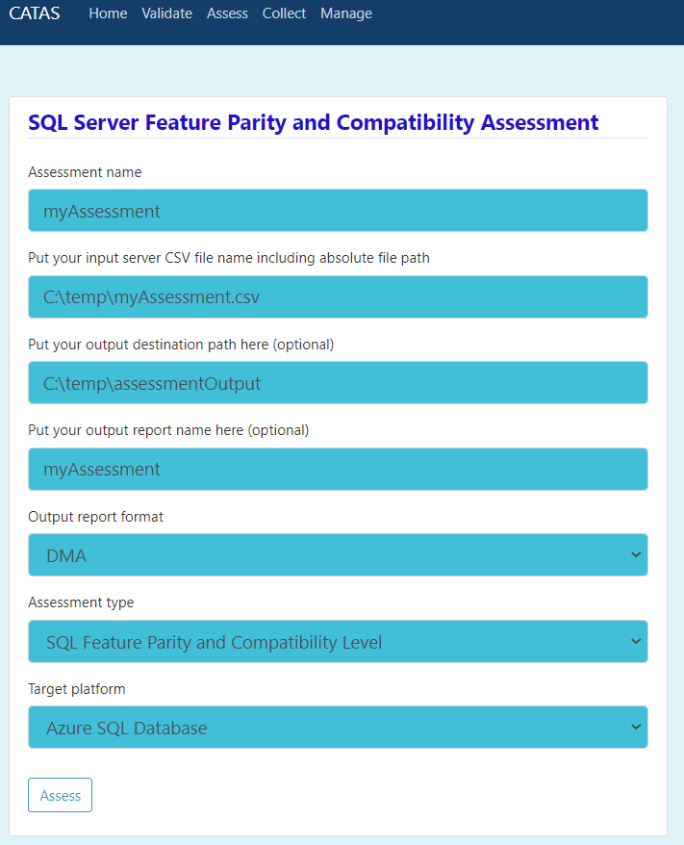
Figure 5 Assessment Module

CATAS set all default values and you should check them to make sure they meet you expectations.

Collection Module

The Collection module allows you to collect SQL Server workload and make Azure target platform cost estimation based on the collected workload. All required parameters for this module are shown in Figure 6.

Note that the minimum collection time is 240 seconds (4 minutes), but we recommend between 4 to 8 hours. The workload collection should be conducted during production peak time to reflect highest workload scenarios.
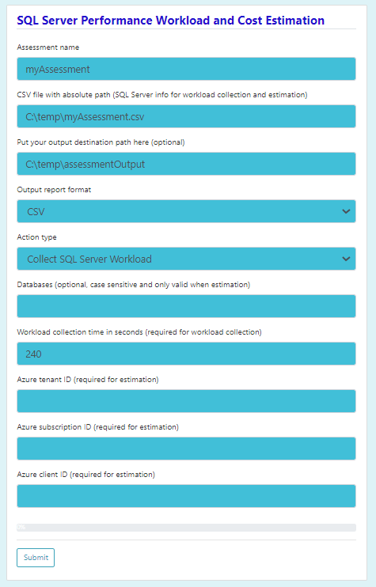
Figure 6 Workload Collection and Cost Estimation

Management Module

The Management module allows you to save current assessment configuration to a json file for future usage or to load a previous assessment configuration to run. Figure 7 displays the functionality.

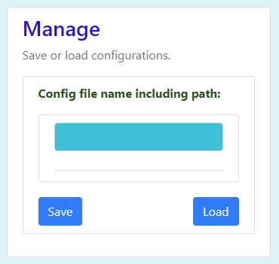
Figure 7 Assessment Management

Validate all SQL server

Appendix A – Glossary

Acronym | Meaning
ADMS | Azure Data Migration Service
BACPAC | a ZIP file with an extension of BACPAC containing the metadata and data from the database
CATAS | Compugen Assessment Tool for Azure SQL
DMA | Database Migration Assistant
SQL | Structured Query Language
SQL DB | Azure SQL Database
SQLCMD | SQL Server Command Line Interface
SSMS | SQL Server Management Studio

